**Part 2**

c. Predict the packet path to resolve **www.web.pka** to an IP address. Record your prediction.

**DNS packets: PC0 > Wireless Router0 > Cable Modem0 > Cloud0 > Router5 > East > Switch0 > Switch1 > Public DNS and reverse the path back to the originator PC0.**

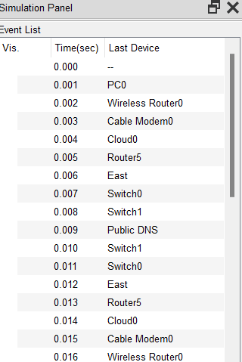

d. After the IP address has been resolved, which path did HTTP packets travel to display the webpage? Record your observations.

**DNS packets: PC0 > Wireless Router0 > Cable Modem0 > Cloud0 > Router5 > East > Switch0 > Switch1 > Switch2 > www.web.pka and reverse the path back to the originator PC0.**

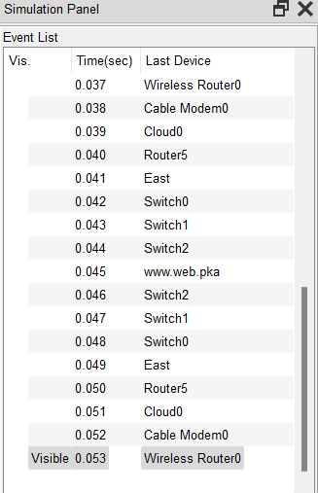

g. With a broken link in the LAN, how did the path change? Record your observation.  
**It went through Switch 0 > Switch2 > Switch1 to reach Public DNS server.**

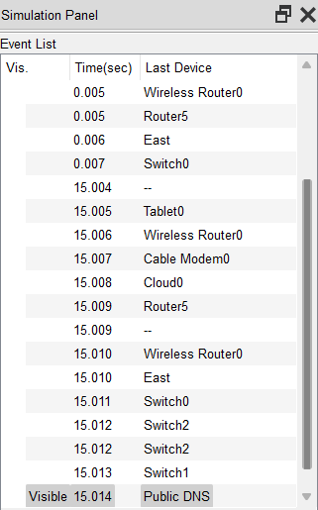

**Part 3**

* **Step 1**

1. Predict the packet path to resolve www.cisco.pka to an IP address. Record your prediction.  
   **DNS packets: PC0 > Wireless Router0 > Cable Modem0 > Cloud0 > Router5 > East > Switch0 > Switch2 > Switch1 > Public DNS and reverse the path back to the originator PC0.**

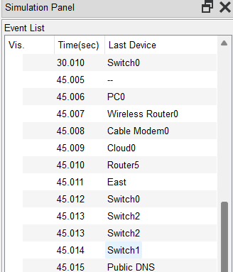

1. After the IP address has been resolved, which path did HTTP packets travel to display the webpage? Record your observations.  
   **DNS packets: PC0 > Wireless Router0 > Cable Modem0 > Cloud0 > Router5 > Router2> Router4 > West > Switch > www.cisco.pka and reverse the path back to the originator PC0.**

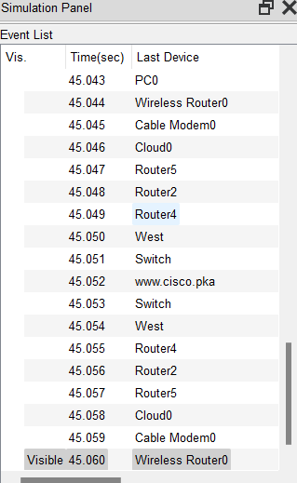

1. With a broken link in the WAN, how would the path change? Record your observation.  
   **It will go through Router2 > Router3 > Router4 to** [**www.cisco.pka**](http://www.cisco.pka)**.**

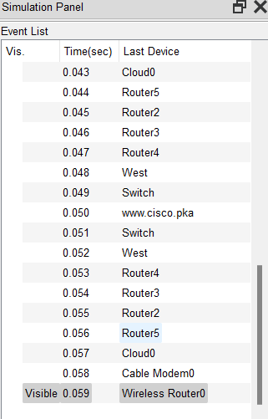

* **Step 2**

|  |  |  |  |
| --- | --- | --- | --- |
| **Trace Number** | **Device** | **Interface** | **IP Address** |
| 1 | blank | GigabitEthernet 0/1 | 192.168.0.1 |
| 2 | blank | Serial 0/1/1 | 209.165.200.225 |
| 3 | Router3 | Serial 0/0/0 | 192.0.2.2 |
| 4 | Router2 | Serial 0/0/1 | 192.0.2.18 |
| 5 | Router5 | Serial 0/1/1 | 192.0.2.26 |
| 6 | East | Serial 0/0/0 | 209.165.202.130 |
| 7 | www.web.pka | NIC | 209.165.202.132 / 192.168.2.254 |

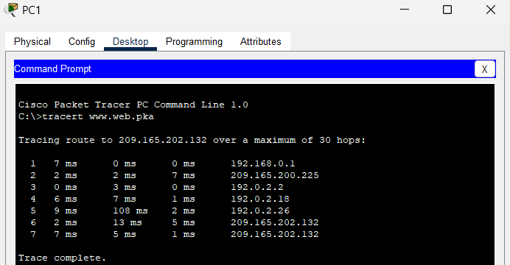

1. Compare the tracert results to the simulation results for the HTTP packets. Record your observations.  
   **The tracert and simulation results both show the same path to the web server.**

